**Name Pronunciation tool- Techgigs**

**Home Page**

The home page contains the user name of the employee fetched from the Azure AD service. The logout button when clicked will logout(Microsoft account) the user from the application

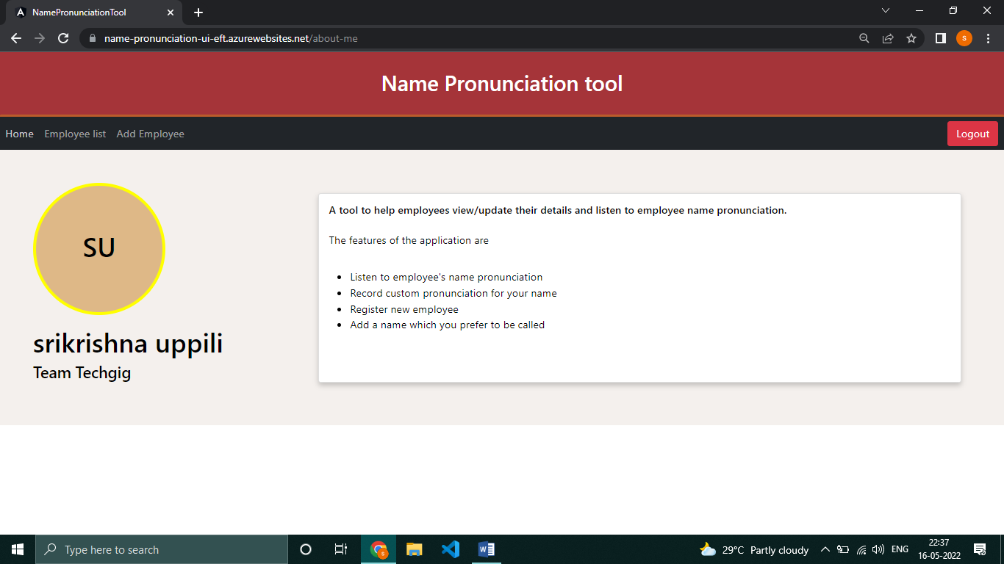

**Employee list**

The contains the list of all employees registered in the application. The employee can listen to the name pronunciation of any employee in the list. The logged in user alone will have options to provide custom pronunciation recording and updating their preferred name. Additional features for searching employees and pagination is also provided.

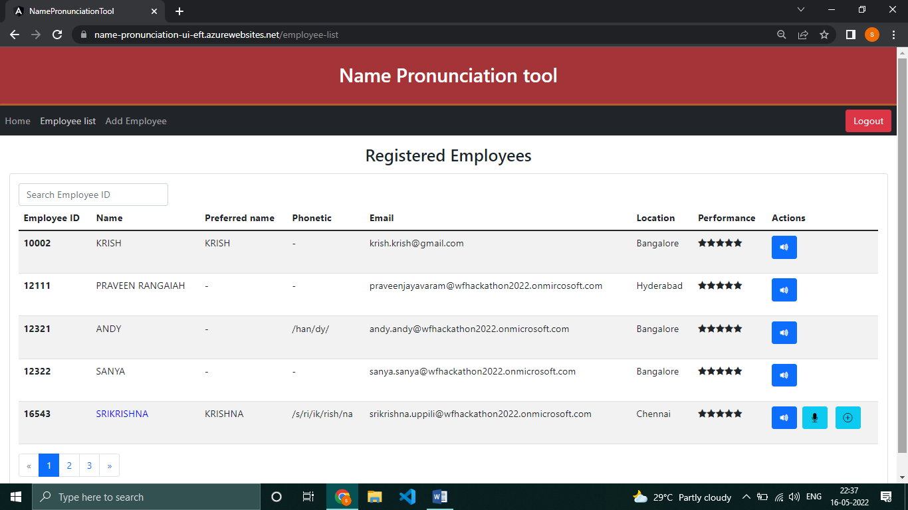

**Add Employee**

This page is used to register new employees in the application. The pronunciation of the employee name can be played while filling out the form. The preferred name also be set as default name while registration. The summary will be shown after filling the form which can be verified and submitted.

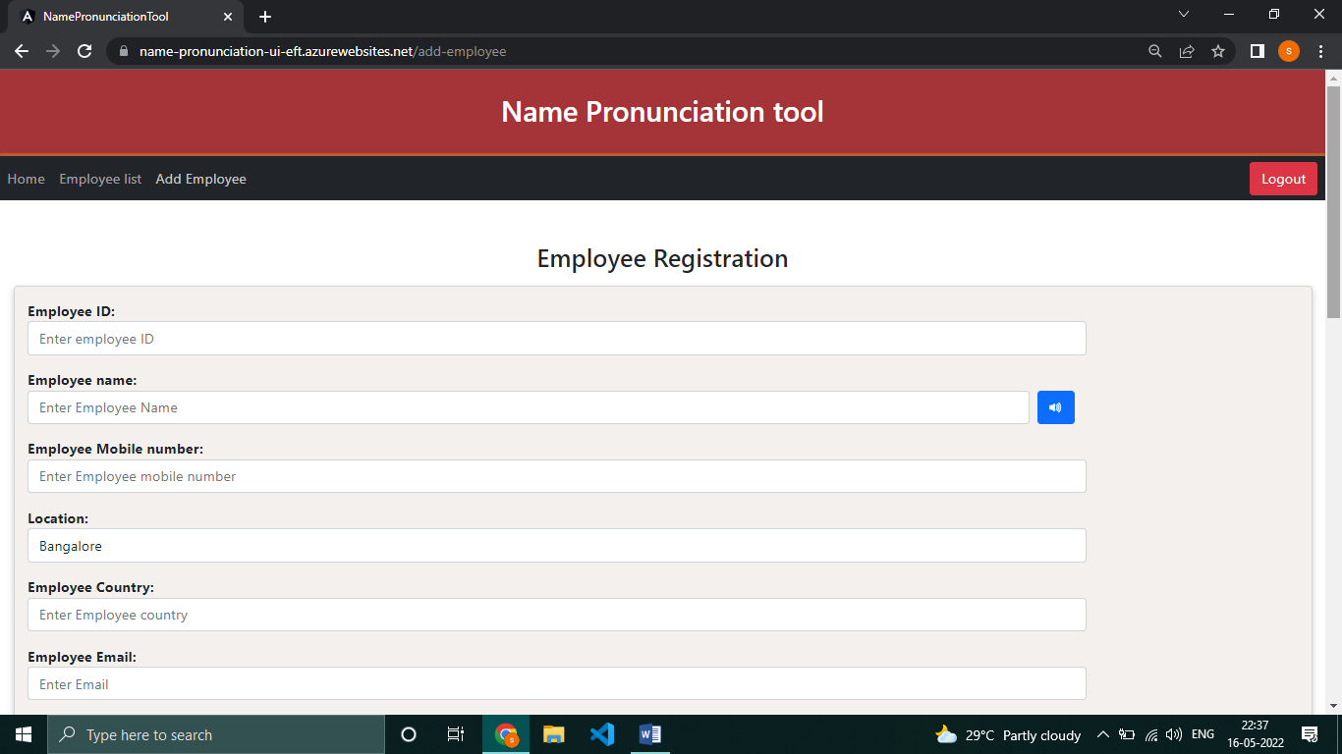

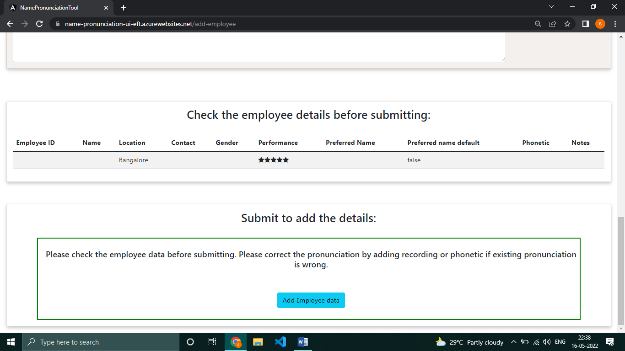

**Play Pronunciation**

**Click on the speaker icon to play pronunciation for a particular employee name**

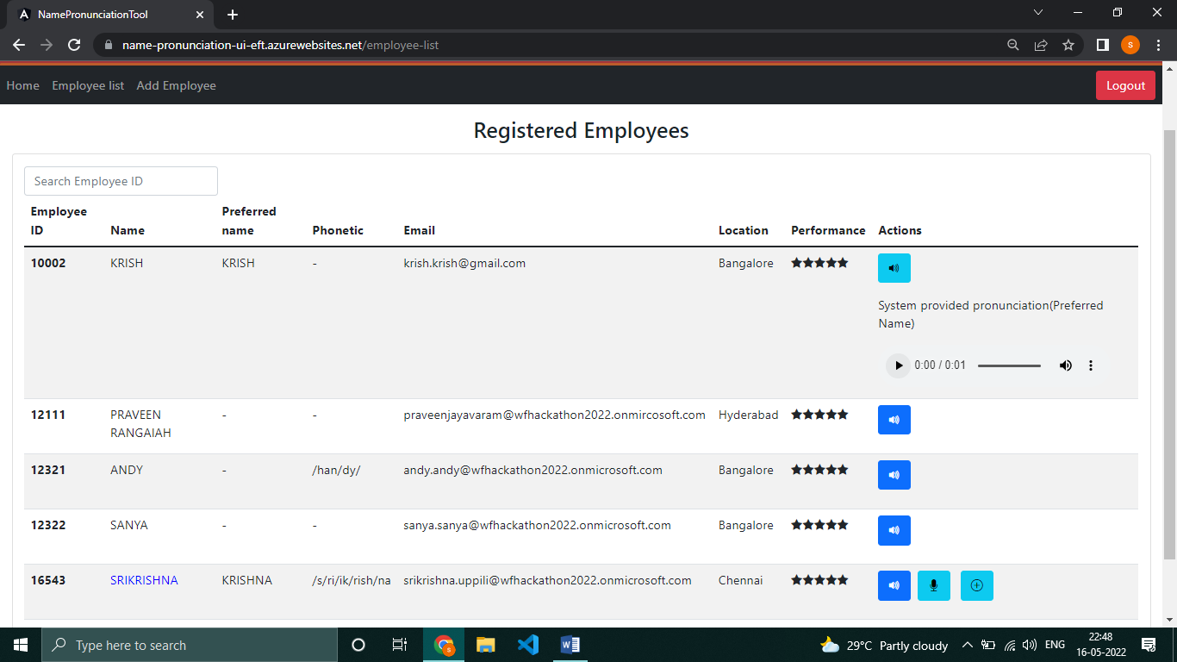

**Slow/fast pronunciation**

Adjust the speed of the pronunciation by adjusting the playback speed in the player.

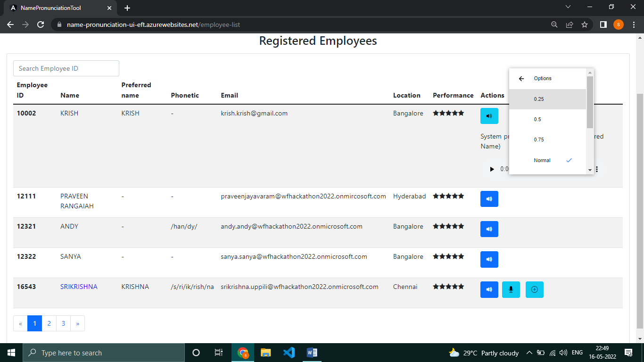

**Record pronunciation option**

Click on the mic icon to start recording. The recording will be stored in Azure storage service. This recording will be played in future instead of the system generated pronunciation.

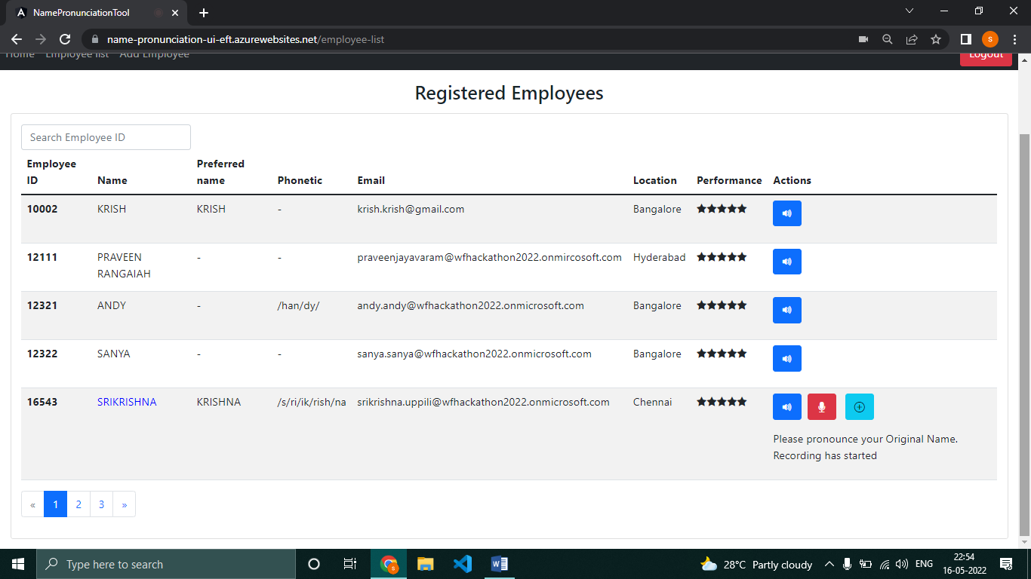

**Update Details**

When the update details icon is clicked, the user will be able update their preferred name, set their preferred name as default and set phonetics for their name.

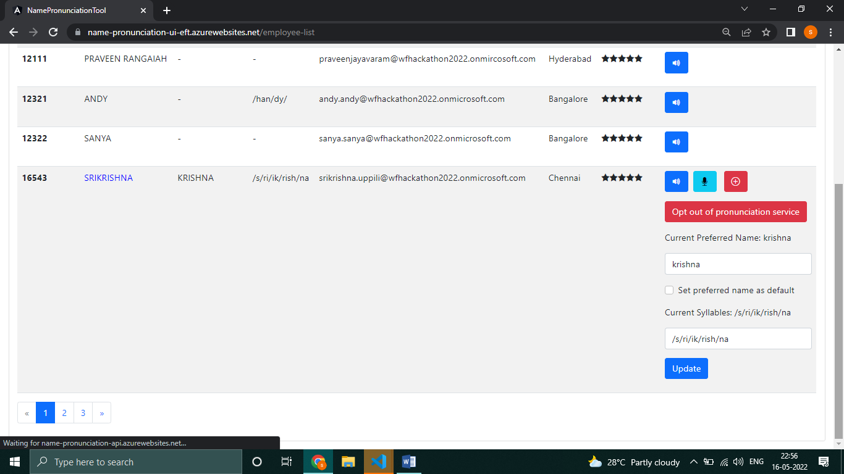

**Set Preferred name**

The employee can update their preferred name and set preferred name as default. When preferred name is set as default, the system generated pronunciation will pronounce the preferred name instead of default name.



**Opt out of pronunciation service**

When user clicks this button, the employee recorded pronunciation data will be removed. After this, the system generated pronunciation will be played instead of custom pronunciation.



**Conditions covered**

* Play employee provided pronunciation when employee recorded their name pronunciation
* If employee didn’t provide custom pronunciation, play system generated pronunciation
* If employee set their preferred name as default, set system generated pronunciation for preferred name instead of default name.

**Login/logout service**

Using Microsoft AD service, the application can be accessed only with valid hackathon mail ID. The logout option when clicked, will log out the employee from the application.

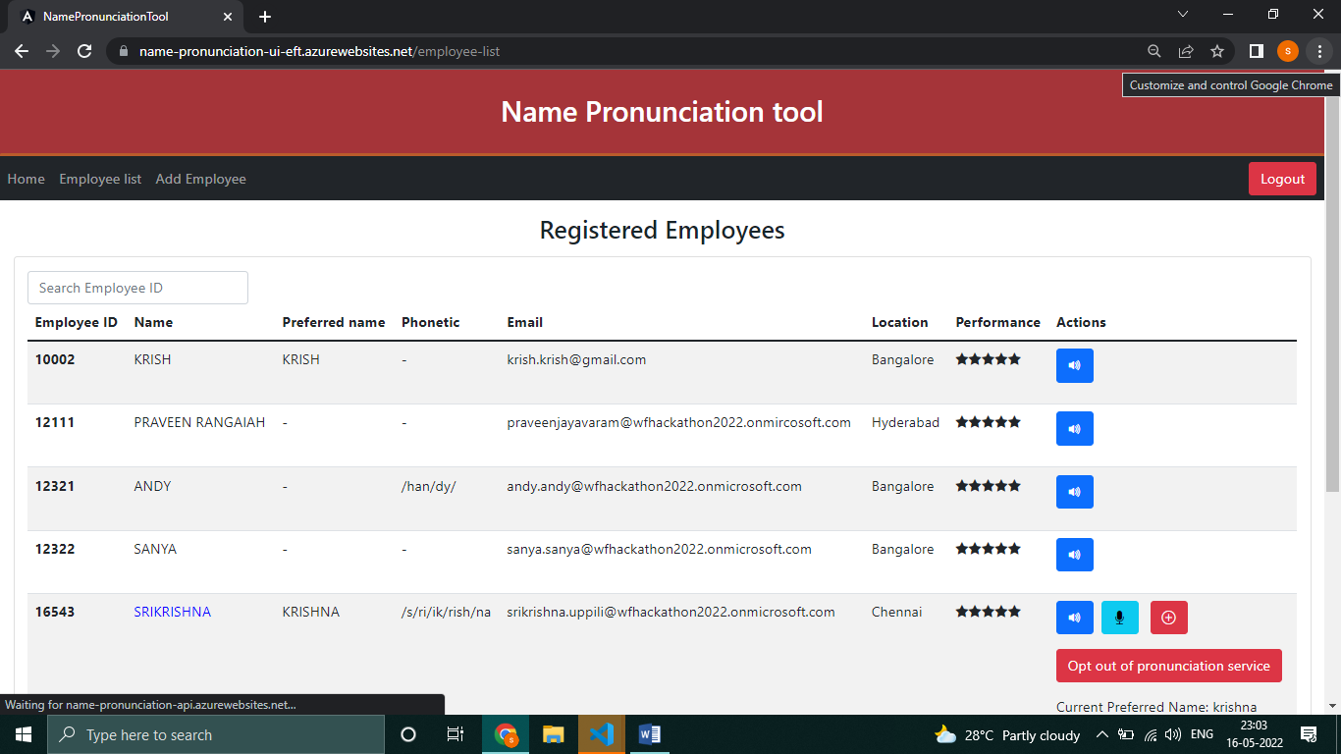

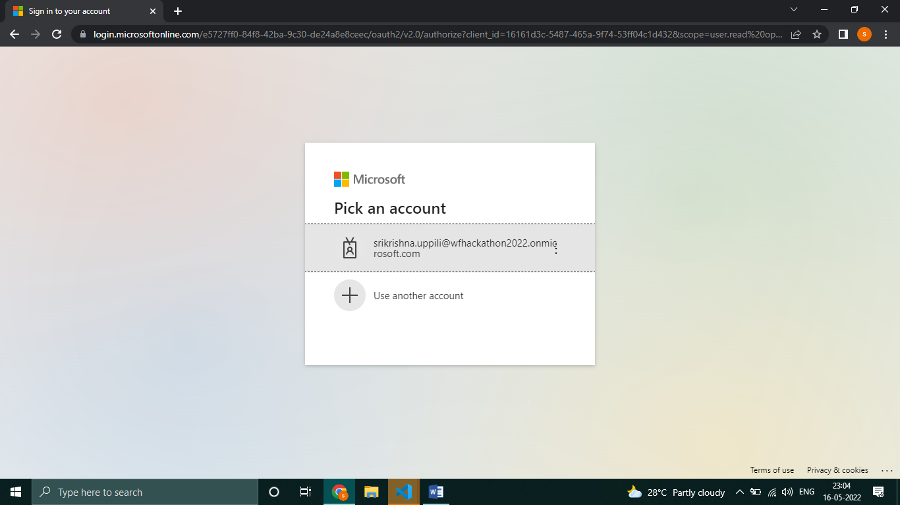

**CICD pipeline**

The code is being deployed to app service by CICD pipeline with Github. The workflows can be found here

UI workflow: <https://github.com/techgig-EFT/techgig-hackathon2022-UI/blob/main/.github/workflows/main_name-pronunciation-ui-eft.yml>

API workflow: <https://github.com/techgig-EFT/techgig-hackathon2022-API/blob/main/.github/workflows/main_name-pronunciation-api.yml>

**Important Links**

* **Application-** <https://name-pronunciation-ui-eft.azurewebsites.net/>
* **API-** <https://name-pronunciation-api.azurewebsites.net/>
* **GitHub UI-** <https://github.com/techgig-EFT/techgig-hackathon2022-UI>
* **GitHub API-** <https://github.com/techgig-EFT/techgig-hackathon2022-API>
* **Demo video-** <https://sqlvaexw675lswetoy.blob.core.windows.net/vulnerability-assessment/demo/name_pronunciation_tool_TechGigs.mp4>